CHANGE… a Human Process that’s Normal and Healthy

Changing organizations requires new ways of thinking – changes in paradigms, systems and procedures.

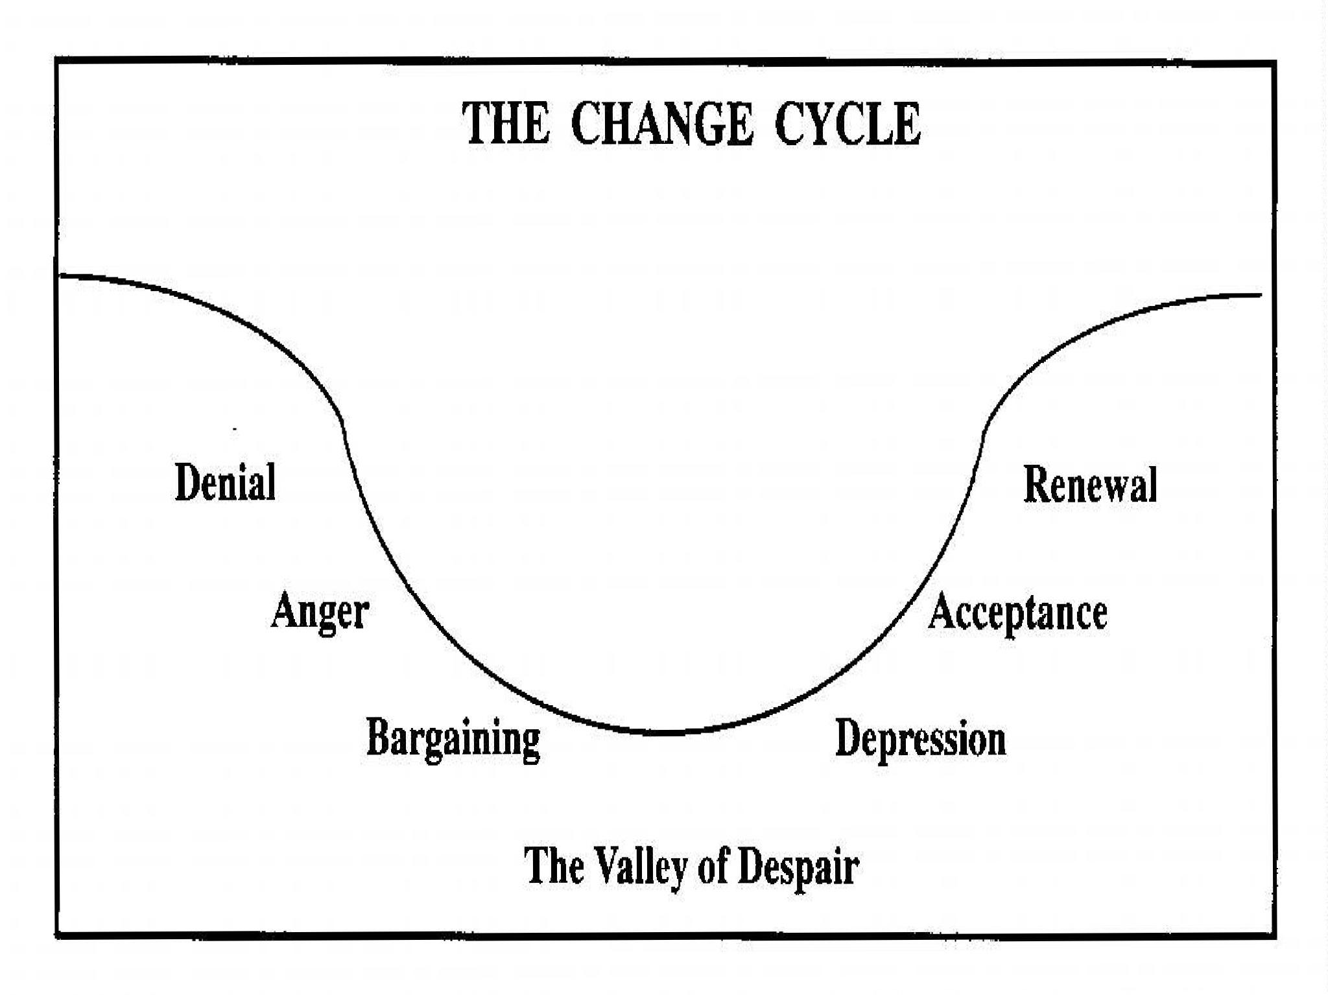Change brings about decisions and decisions bring consequences. These consequences often cause a sense of loss. Organizations and individuals often focus more on protecting than achieving. Thus, the fear of loss is greater than the desire for gain.

The trust level within the organization also impacts an individual’s willingness and ability to accept and work through the change process. “I know they wouldn’t do anything that would be harmful to the organization and its members. I’ve worked with them for years and have learned to respect and trust their leadership.” This level of trust, earned over time, through honest, intimate and open dealings, is difficult to establish. Especially when one recognizes how the old paradigms of maximum profitability through technology at the expense of human growth impacted employees. Organizations have used people and allowed technology to drive their decision, under-valuing the employees’ learning capabilities and intelligence.

One’s reactions to change are dependent on one’s acceptance of the change. This can be significantly impacted by the degree of involvement in creating it. If individuals don't genuinely feel part of the change process, denial and even anger can appear. Kubler Ross’ (1969) change cycle applies, not only to individuals, but to groups and organizations (Bridges, 1988; Grayson and O'Dell, 1988).
These stages are normal and healthy to be expected and grown through.

They are described as:

• Denial and Disbelief
• Anger and Blaming
• Bargaining, Testing and Buying Time
• Retreat and Depression
• Adjustment, Acceptance and Renewal

Denial – denial is a means of protecting oneself from issues that violate an individual’s view of reality. Characteristic responses illustrating denial include:
• It can’t be. Why, that’s impossible;
• Change isn’t really required. We don’t do things that way;
• It won’t really happen. It’s too radical a change;
• Here comes another program, fad or gimmick
• Just wait and see, it’ll blow over;
• We have the best. Didn’t we teach them?;
• We’re a fine company. All we need to do is what we know how to do best and we’ll be just fine;
• A search for simple solutions. “If we would only do this, we wouldn’t need to change.”

Resistant managers like this phase because they don’t have to deal with the actual pain of loss. They often will form cliques with others to fight the change, in an effort to keep from facing the need for change. Again, keeping people involved in the basic rationale and facts helps individuals understand the real need for change.

Anger – anger is a secondary emotion that develops from frustration, fear, hurt or anxiety and is often misdirected. Anger often turns to blaming others. “If it weren’t for those foreigners dumping, we could sell our product.” Too often we espouse the free market or competitive spirit until someone else is better and then yell foul. Anger is, however, often a good sign that the individual’s defensiveness is beginning and the basic need for change is recognized. It is expressed by “I can fight it and maybe stop it.” Once a person realizes change is inevitable, they can begin hearing.

Bargaining – a time of yearning and searching; a time of hope, along with discouragement; a need to hold on, buy some time, but a willingness to face the change. The in-between stage, the attempt to cut a deal so the loss is minimized. Illustrations of bargaining include:

• Excessive cooperation or placating behavior;
• Buying time (“This is a long term effort”);
• A willingness to take on some or a few new assignments;
• Concessions (a win/loss strategy - it implies “I get it back later” and possibly more);
• Actions and behaviors have an unreal quality, lack authenticity.

This is a critical period during the change cycle. Managers find this discouragement and sadness hard to deal with and try to make it go away, as opposed to viewing it as healthy and normal. Trying to make the need for change go away doesn’t do much good and blaming may drive the behavior underground. Encourage open dialogue; it’s the best solution for working through the difficulties and differences.

Depression – the neutral zone, a time of confusion and emptiness. One feels disoriented, alone, powerless, and unable to control. It’s that strange valley in the gap between the old and the new. No more excuses, each must look inside themselves as individuals and organizations, owning the incompetency. It’s an opportunity for creating the needed change about which some have dreamed. The more one is able to leave behind, the more room one has for the new.

Acceptance – one can come to new beginnings only at the end. There’s a new energy released by letting go of the old. There is a real readiness to move forward. People will say, “It’s really going to happen, and I can have a significant role in making it happen. Let’s get on with it.” Let’s just “do it.”

The real evidence that people have let go of the old way is characterized by:

• Lack of bargaining and negotiating;
• Less chasing after simple solutions;
• Genuine interest in exploring new alternatives;
• A real understanding that they must create the new.

These new beginnings call for a clarification of the roles and responsibilities that go beyond our traditional understanding of manager, supervisor, employee, etc.

Hopefully, these five phases will help us understand why change is so difficult and slow. However, it’s working through these stages that is critical and allows for true renewal to take place; a process that’s painful but unavoidable and essential if we are to survive and grow.

